主题：村庄变迁

题型：地图

The map shows the village of Chorleywood showing development between 1868 and 1994

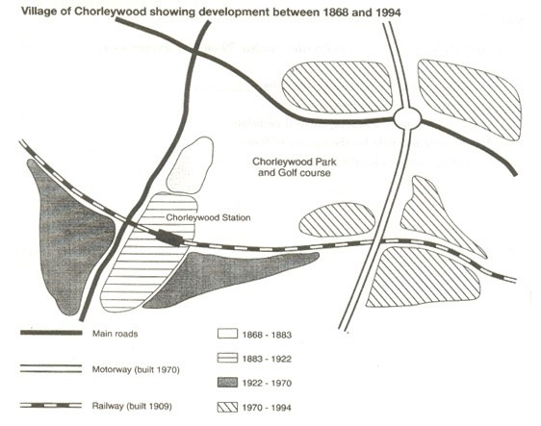

满分范文：

The map shows the growth of a village called Chorleywood between 1868 and 1994.

It is clear that the village grew as the transport infrastructure was improved. Four periods of development are shown on the map, and each of the populated areas is near to the main roads, the railway or the motorway.

From 1868 to 1883, Chorleywood covered a small area next to one of the main roads. Chorleywood Park and Golf Course is now located next to this original village area. The village grew along the main road to the south between 1883 and 1922, and in 1909 a railway line was built crossing this area from west to east. Chorleywood station is in this part of the village.

The expansion of Chorleywood continued to the east and west alongside the railway line until 1970. At that time, a motorway was built to the east of the village, and from 1970 to 1994, further development of the village took place around motorway intersections with the railway and one of the main roads.